Class Tasks

Task#1
Create a form similar to the below one.

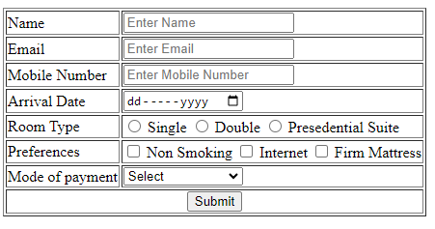

Task#2
You have to create the webpage similar to the below one.
